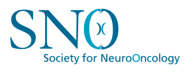
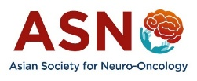

2026 ASNO-SNO Clinical Trials Scholars Course for Neuro Oncology
Concept Development Workshop (CDW)
11th June, 2026, ASNO Annual Congress, Kanazawa, Japan

APPLICATION FORM

Name:

Gender:

Professional Status/Title:

Clinical Discipline:

Employment/Place of work:

Academic affiliation/Institution:

Preferred Contact Address:

Telephone:
Email:

Nationality:

Country of Residence:

Completed Specialty and year of completion:

Or

Current Year of Specialty (any branch related to Neuro-Oncology; e.g Neurosurgery, Radiation Oncology, Neurology, Medical Oncology, Pathology, Radiology etc)

Expected Year of Completion:

ASNO membership # (mandatory):

Attended any other clinical trials workshop? Yes/No
Confirmation to have completed all course lectures on the ASNO website Yes/No

Supervisor/Guide’s Name
Address:
Telephone:
Email:
Supervisor Statement document to be uploaded
CV
To be uploaded

